Pharma Industry
November ‘17
India has established itself as a global manufacturing and research, making the Indian pharmaceutical market the third largest in terms of volume and thirteenth largest in terms of value. India is the largest provider of generic drugs globally with the Indian generics accounting for 20 per cent of global exports in terms of volume, while on domestic front generic drugs accounts for around 70 per cent of the India's pharmaceutical market.
On the global front, India enjoys an important position on the back of large pool of scientists and engineers who have the potential to steer the industry ahead to an even higher level. Presently over 80 per cent of the antiretroviral drugs used globally to combat AIDS (Acquired Immuno Deficiency Syndrome) are supplied by Indian pharmaceutical firms. The domestic pharmaceutical industry is expected to grow at a compounded annual growth rate (CAGR) of 22.4 per cent to touch $55 billion by 2020, from $20 billion in 2015. A large raw material base and the availability of a skilled workforce give the industry a definite competitive advantage.
Current scenario
The Indian pharmaceuticals market witnessed growth at a CAGR of 5.64 per cent, during 2011-16, with the market increasing from $20.95 billion in 2011 to $27.57 billion in 2016. The industry's revenues are estimated to have grown by 7.4 per cent in FY17. By 2020, India is likely to be among the top three pharmaceutical markets by incremental growth and 6th largest market globally in absolute size.
India's cost of production is significantly lower than that of the US and almost half of that of Europe, giving it a competitive edge over others. Increase in the size of middle class households coupled with the improvement in medical infrastructure and increase in the penetration of health insurance in the country will also influence the growth of pharmaceuticals sector.
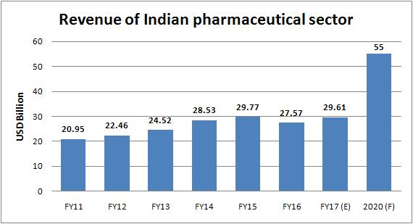
Exports
India is the world's largest provider of generic medicines; the country's generic drugs account for 20 per cent of global generic drug exports (in terms of volumes). Indian pharma companies are capitalising on export opportunities in regulated and semi-regulated market. The exports of Indian pharmaceutical products have reported marginal rise of 0.16% in FY17 to $12,930.48 million from $12,910.04 million in FY16. However, India's pharmaceutical exports has registered a negative growth of 4 percent during the first five months of the financial year 2017-18, mainly due to increased regulatory issues along with pricing pressure in global markets. The pharma exports to other countries declined by 7.9 percent during the April-July period, while recovered to 4 percent in the month of August leaving the overall growth at minus 4 percent till August this year. Pricing pressure is one of the factors for decline in exports. Factors such as import alerts by US Food and Drug Administration (USFDA) on Indian plants, regulatory issues and currency fluctuation, also contributed to downward growth.
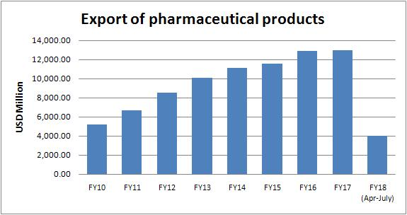
Imports
India managed to control pharma import from past 3-4 years, as government took several initiatives to boost local production. Moreover, the government is working on a zero dependant manufacturing mechanism in order to reduce the dependancy on imports. Imports of pharmaceutical products increased marginally at $1,717.51 million in FY17 as compared to $1,641.15 million in FY16.
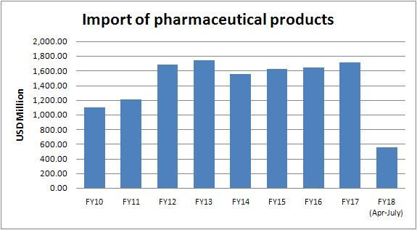
Robust Growth in Biotech Industry
Growing at a faster pace, in comparison with the last couple of years, the Indian biotech industry witnessed YoY growth of 57.14 per cent in FY16; the total industry size stood at $11 billion by FY16 and estimated to have reached $11.6 billion in FY17. Fast-paced growth in the industry is likely to continue, driven by a range of factors such as growing demand, intensive R&D activities and strong government initiatives. The Indian biotech industry comprises of around 800 companies. In order to achieve market size of $100 billion by 2025, the industry has requested Government of India to invest $5 billion to initiate research activities and develop infrastructure as well as human capital. Clinical capabilities are developing fast and the country is becoming a popular destination for clinical trials, contract research & manufacturing activities. India biotech start-ups attracted investments worth $2.8 billion between 2012 and February 2017.
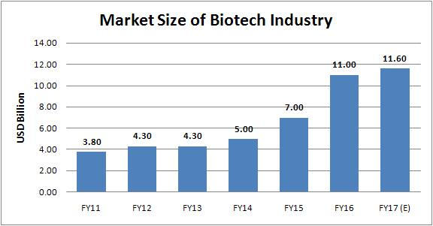
India is becoming a leading destination for clinical trials, contract research & manufacturing activities which is leading to the growth of bio services sector. The bio-pharmaceutical segment accounted for largest revenue share of 64 per cent in Indian biotech industry, during FY16. The bio-services & bio-agri segments accounted for 18 per cent & 14 per cent of the biotech industry, respectively in FY16.
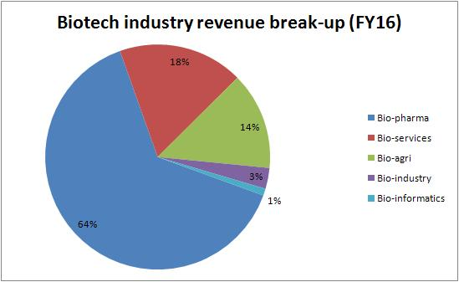
R&D spending in pharmaceutical sector
In FY17, highest expenditure on research and development (R&D) was done by Sun Pharma, followed by Lupin. Sun Pharma's R&D spending was 7.6 per cent of the total sales in the FY17, growing at a CAGR of 38.3 per cent from FY11 to FY17. Sun Pharma's R&D plan includes developing more products through expanded R&D team for global markets, focussing on more complex products across multiple dosage forms and investments in speciality pipeline. Lupin's R&D spending was 13.5 per cent of sales in FY17, with major thrust on oral solids (45 per cent of R&D spend).
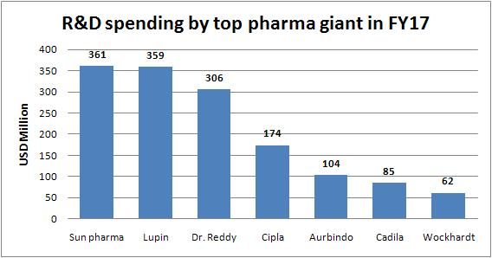
FDI in pharma sector
The drugs and pharmaceuticals sector attracted cumulative FDI inflows worth $14.71 billion between April 2000 and March 2017. Meanwhile, the sector has attracted FDI equity worth Rs 5,722.69 crore or $857.39 million in FY17 as compared to Rs 4,815.80 crore or $728.63 million in FY16. The Union Cabinet gave its nod for the amendment of the existing Foreign Direct Investment (FDI) policy in the pharmaceutical sector in order to allow FDI up to 100 per cent under the automatic route for manufacturing of medical devices subject to certain conditions.
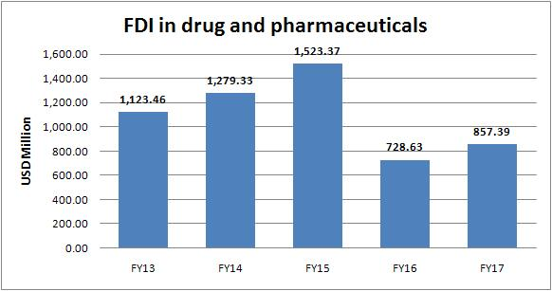
Government initiatives
- The Government of India unveiled 'Pharma Vision 2020' aimed at making India a global leader in end-to-end drug manufacture. Approval time for new facilities has been reduced to boost investments.
- The government introduced mechanisms such as the Drug Price Control Order and the National Pharmaceutical Pricing Authority to deal with the issue of affordability and availability of medicines.
- The government has announced setting up of chemical hubs across the country, early environment clearances in existing clusters, adequate infrastructure, and establishment of a Central Institute of Chemical Engineering and Technology.
Recent developments
Draft Pharma Policy proposes massive dilutions in powers of NPPA
The government is going to dilute the powers of the National Pharmaceutical Pricing Authority (NPPA), the body that regulates drug prices, as the Draft Pharmaceutical Policy, 2017, which focuses heavily on prices of medicine, has proposed massive dilutions in the existing framework, which would give more control to the government over the operations of the NPPA. The draft attempts to strip the NPPA of some powers, like once the price for a drug is fixed the pricing authority would not be allowed to revise them. The NPPA would also lose its power to cap the prices of in-patent medicines, and would be able to use its 'emergency powers' only on the government's orders. It states that 'this Policy would significantly contribute to the Ease of Doing Business in the pharmaceutical sector. The 'Make-in-India' programme would also get an impetus by the actions'. Further adding that 'the regulator and the government would be two distinct agencies, the government shall not be the regulator and the regulator shall not be the government,' yet a government-appointed advisory body, with representation from the government, industry, as well as civil society, is being proposed. The draft pharmaceutical policy, prepared by the department of pharmaceuticals under the ministry of chemicals and fertilizers, has proposed that an advisory body, members of which will include industry representatives nominated by the government, will assist the NPPA in fixing prices. The government will prepare the list of medicines for price regulation and transmit them to the NPPA for fixing the price ceilings.
Government plan may bring non-essential drugs under price control
The Department of Pharmaceuticals (DoP) is considering a change in the method of approving prices of new drugs. The government's push for a change in the method of price calculation methodology for new drugs can lead to non-essential drugs coming under price control. This proposal relates to doing away with retail price by ceiling price for 'new drugs'. It has potential to bring non- essential drugs under price control, reduce competition and compromise growth. The DoP should instead address the issue of delay in fixing the prices of 'new drugs' by the NPPA. As per the Drugs (Prices Control) Order, 2013, a new drug is described as a formulation launched by an existing manufacturer of a drug of specified dosages and strengths as listed in the National List of Essential Medicines (NLEM) by combining the drug with another drug. It also applies to a formulation launched by changing the strength or dosages or both of the same drug of specified dosages and strengths as listed in the NLEM.
Government forms panel to make drugs more affordable
The government has formed a committee in its bid to make drugs more affordable in the country. It would suggest ways to make pricing policy in favour of poor patients. The committee would also review the scope of Drugs (Price Control) Order 2013 (DPCO 2013) and suggest ways for strengthening the regulatory provisions of the order. It will also delve into making the existing mechanisms for collection of market based data on prices of medicines more robust and stream lined and suggests ways for strengthening the existing pharmaceutical database management system. The panel will also look at procedural improvements and process of re-engineering in NPPA to ensure better and quicker implementation of the government policy and bring greater transparency so as to reduce litigations and review petitions.
Outlook
Indian pharmaceutical sector remains under pressure from quite some time due to decline in revenues from the US markets, its largest overseas market, and increased competition. Moreover, generic adoption reaching saturation levels and regulatory overhang along with base effect catching up too remain a big concern for the sector. Despite all these concerns, Indian pharmaceutical industry is expected to recover in coming time on the back of increasing consumer spending, rapid urbanisation, and raising healthcare insurance. Robust growth in Biotech Industry and higher spending in research and development by the major companies spread ray of hopes for the industry. To bring the pharma industry on right track, the Indian government has taken many steps to reduce costs and bring down healthcare expenses. Speedy introduction of generic drugs into the market has remained in focus and is expected to benefit the Indian pharmaceutical companies. The implementation of the Goods and Services Tax (GST) too is expected to provide fillip to the Indian Pharmaceuticals industry as it will lead to tax-neutral inter-state transactions between two dealers, thereby reducing the dependency on multiple states and increasing the focus on regional hubs.

